FONT SIZE

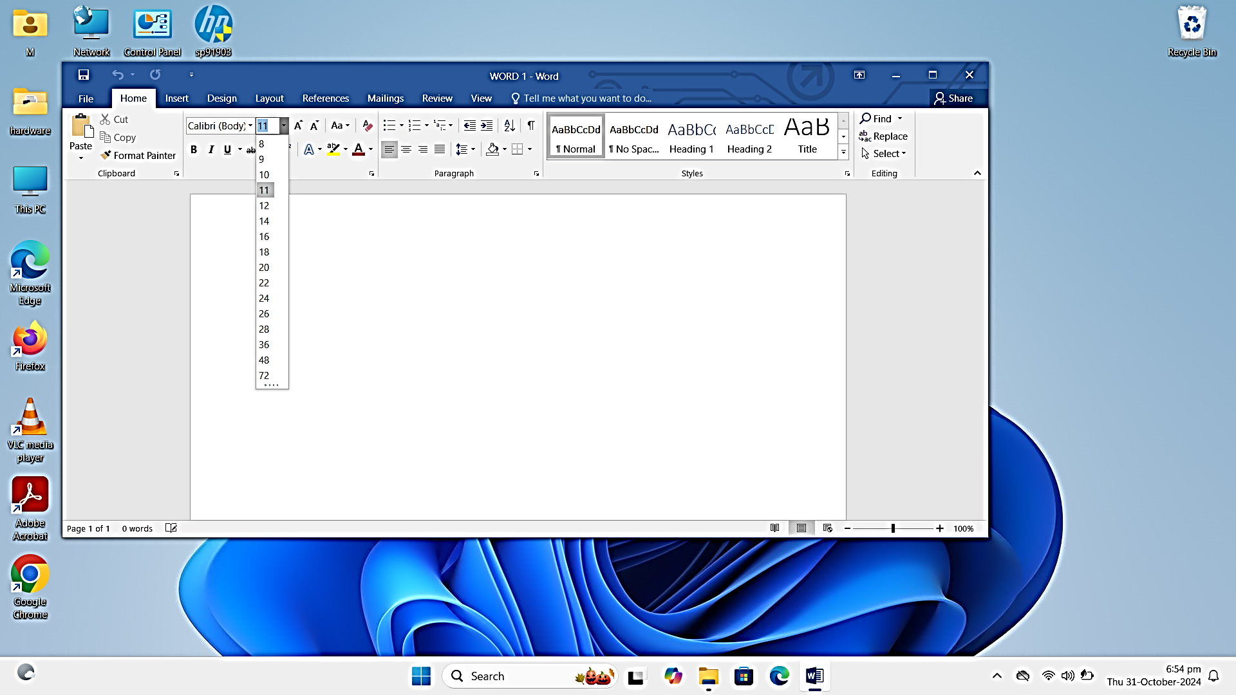

1. Formatting Text: Go to the Home tab which is on the left hand of the screen, select options in the Font group, or open the Font Dialog Box and format the given texts.
2. Font Size: Use the Font Size dropdown in the Home tab, click on it and get the required font like font 12, font 14.

HOW IS WORK

FONT SRTYLE

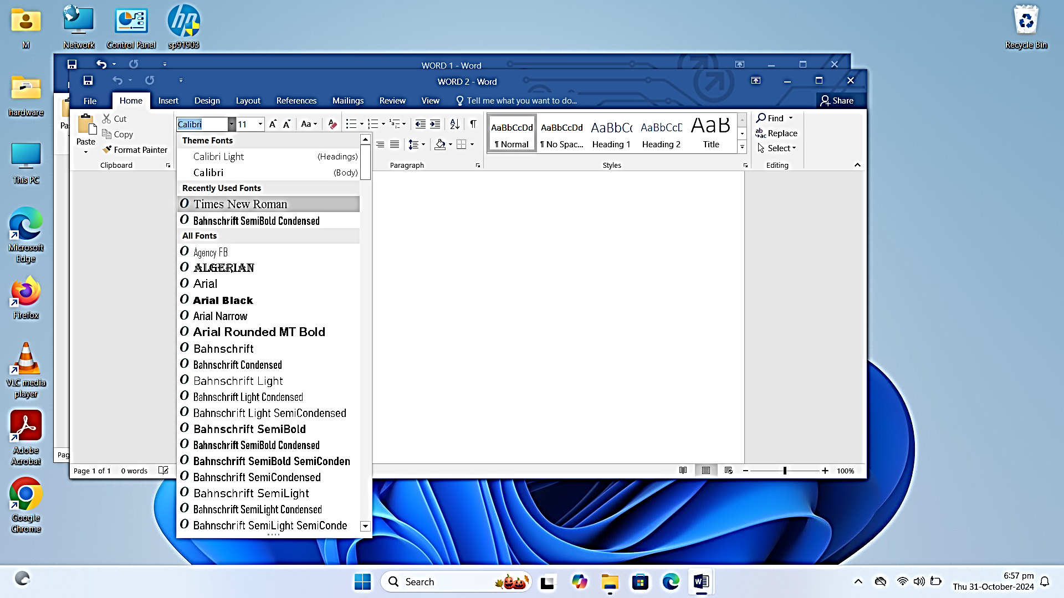

1. Font Style: Go to the Home tab on the left hand, scroll to see various font styles and choose a style from the Font dropdown in the Home tab and apply to the selected text like times new roman, Algeria and Arial.

BOLD ITALIC AND UNDERLINE

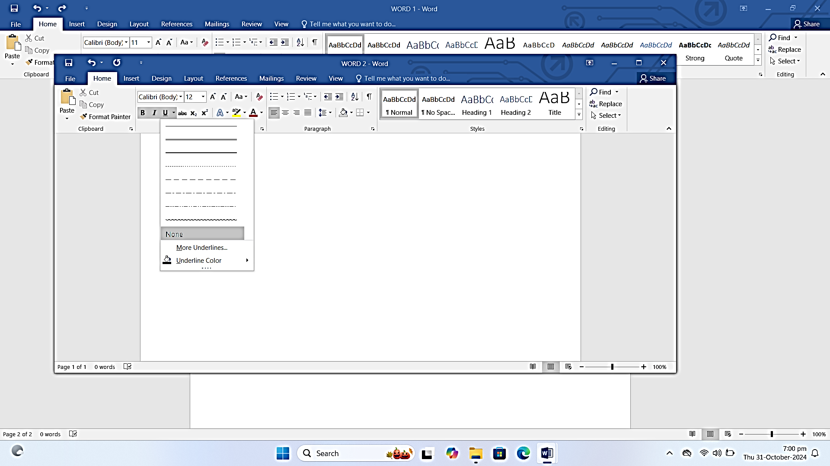

In the home tab, the option for bold is displayed on the screen in the font group with (B) Italic is displayed on the left side of the screen with bold (I) and underline text is also displayed on the left side of the screen with bold (U). They are displayed below the Font style button. OR you can use ctrl +B, ctrl +l, ctrl + U

Examples

Bold: **Computer software**

Italic: *Computer systems*

Underline: data base

**FONT COLOR**

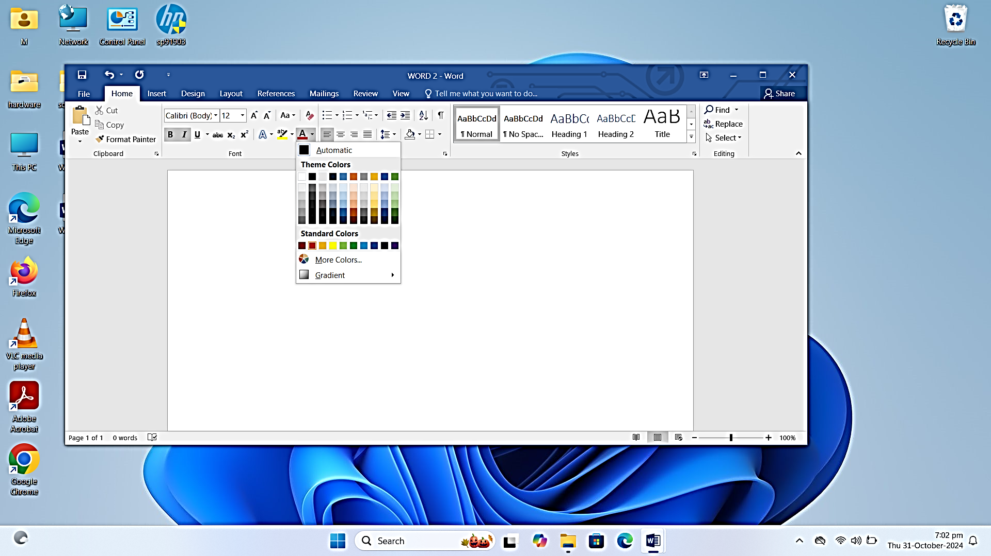

. Font Color: In the home tab, locate the font color button, its represented by an A with a color bar beneath it. Click on the dropdown arrow to open the color palette, and select the color of your own choice and you can get more colors by clicking on more.

**CHANGE CASE**

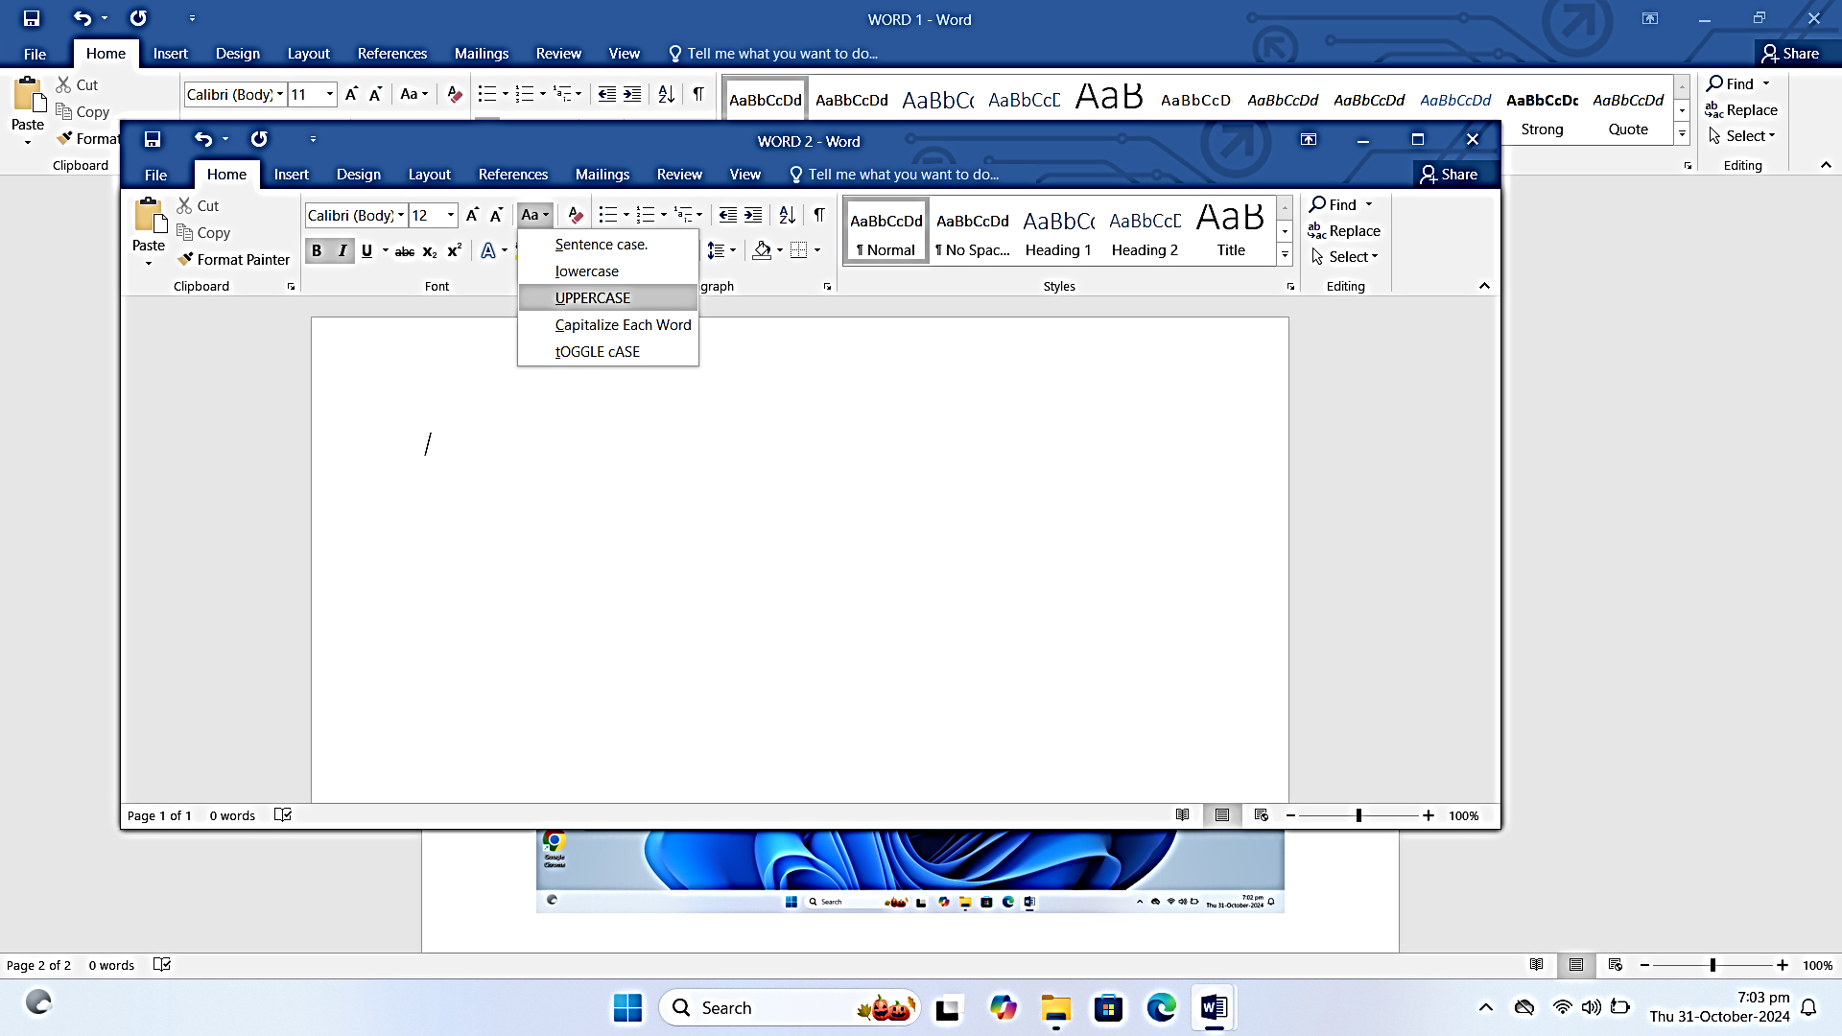

Change Case: In the home tab, find the change case button, which appears as an Aa icon in the font group. You click on the options like sentence case, lower case. Uppercase, capitalize Each Word, or toGGle case. Use the Change Case button ("Aa" icon) in Home to select a case option

For example:

FIRE FOX, mozilla

**WORKING WITH CHARTS**

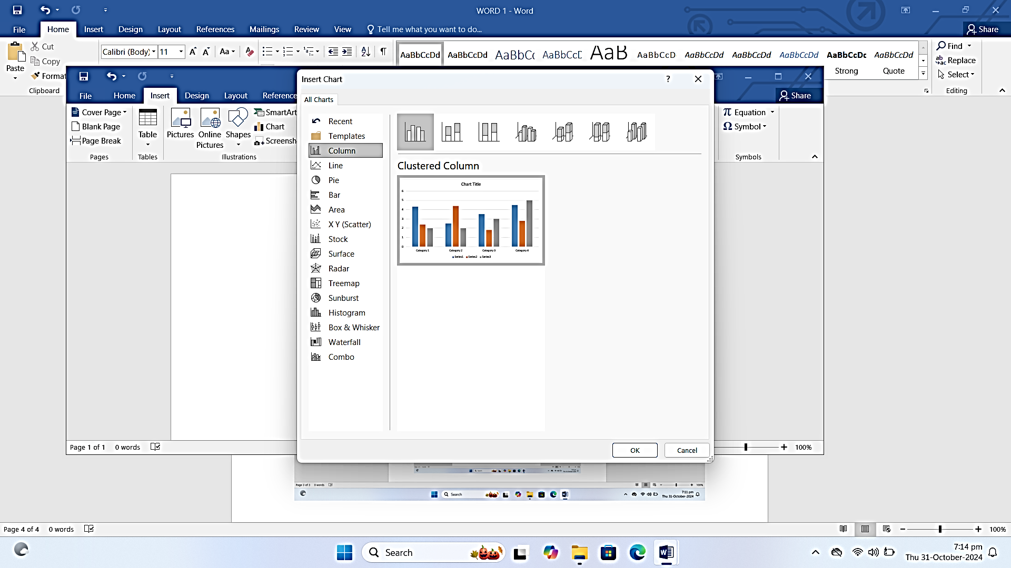

Working with charts; go to the insert tab, near the screenshot before it, select chart, choose the chart based on the type of data you want to insert, input data into the chart and customize the chart by adding labels, colors and title.

WORKING WITH HEADER

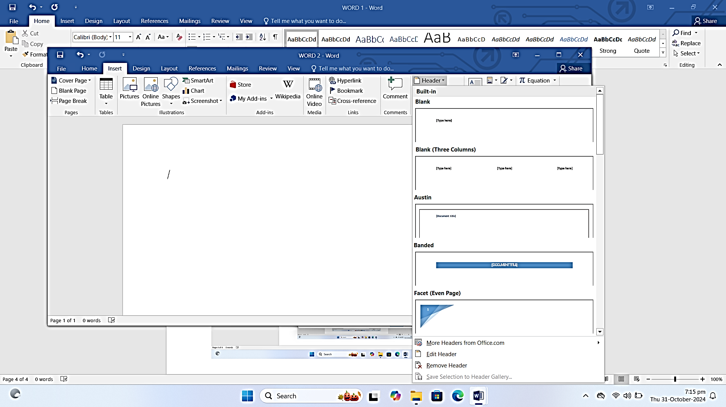

Working with header: Go to the insert button near the comment tab, click on the header and choose the style, type the desired text like document tittle, name and format the text by changing font size or color if needed.

WORKING WITH FOOTER

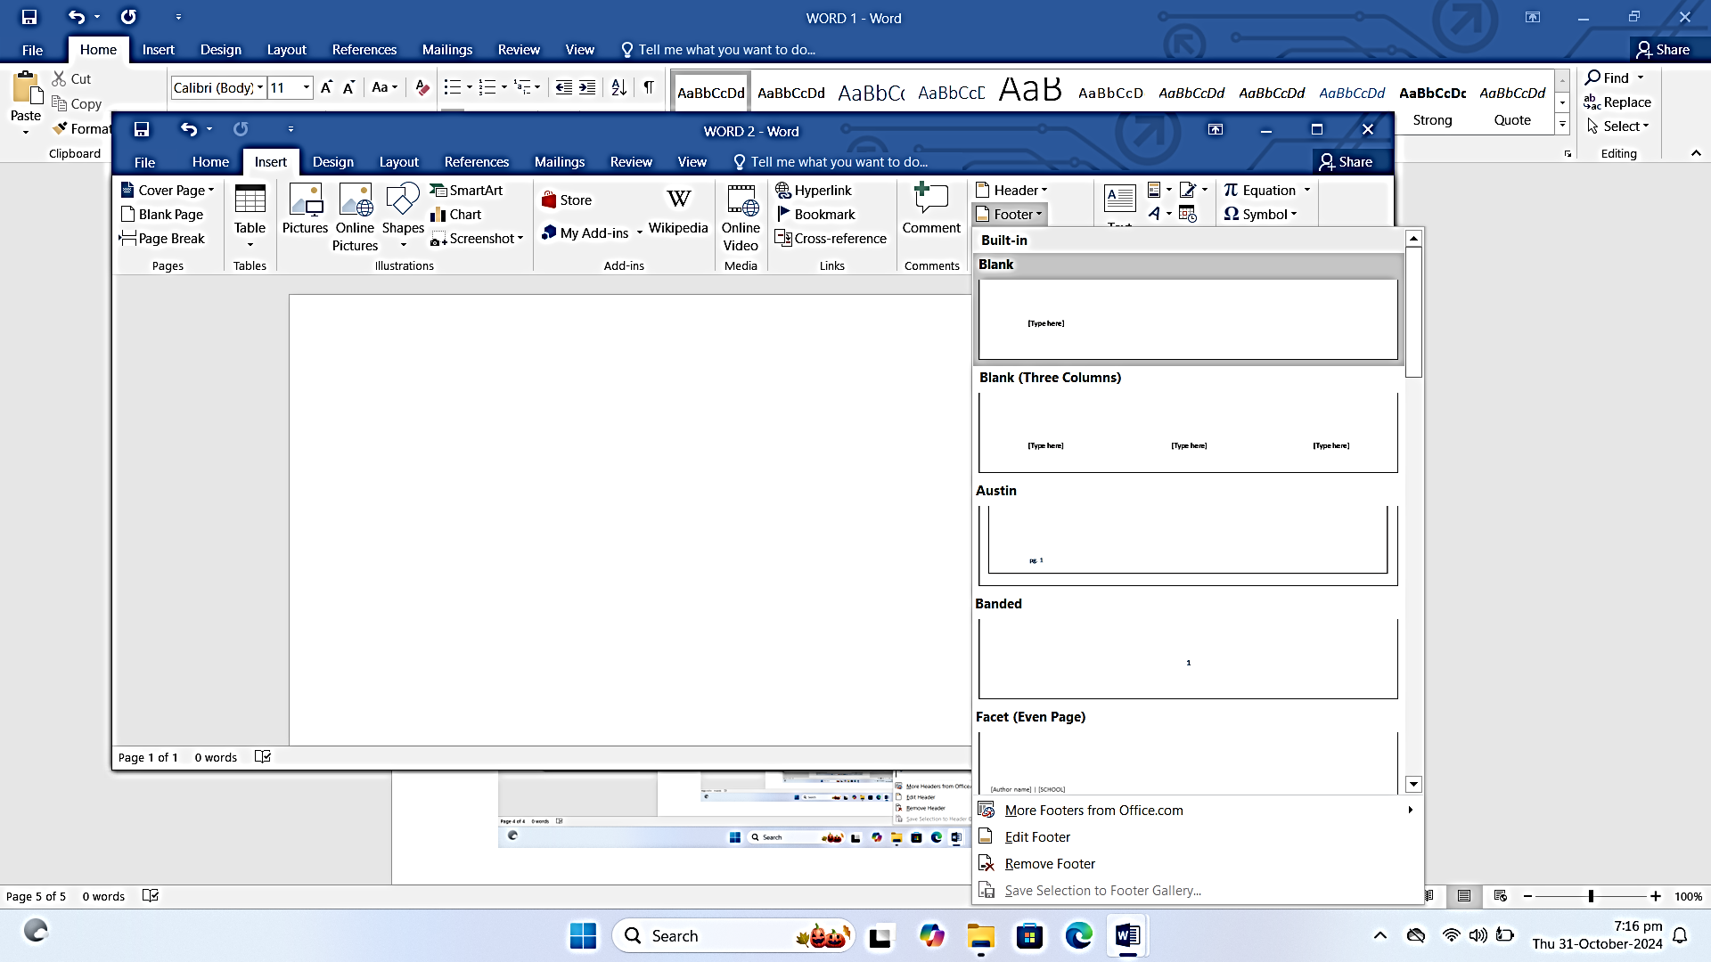

Working with footer: go to insert button near the header, click on the footer and choose the style, type the desired text and format the text by changing font size or color if needed.

***PAGE NUMBER***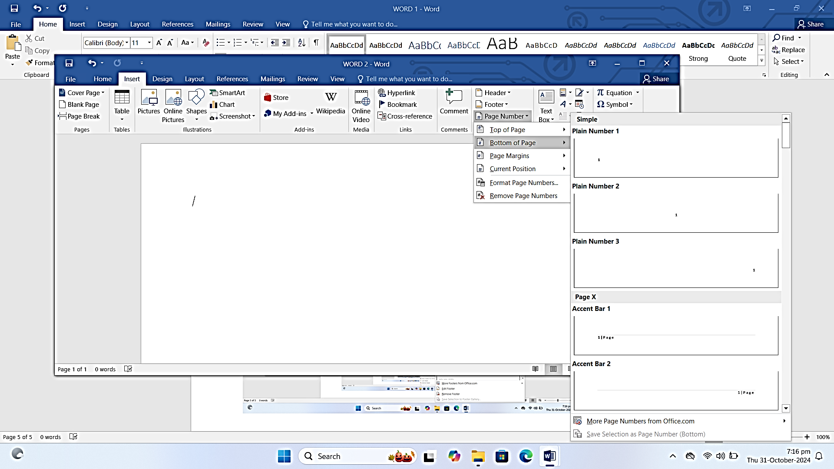

Go to the insert tab ,on the right hand side click on the page number and select where you want to insert the page number like top, ,left or right, choose a format for page numbers like numbers only or numbers with dashes and then customize.

**TEXT BOXES**

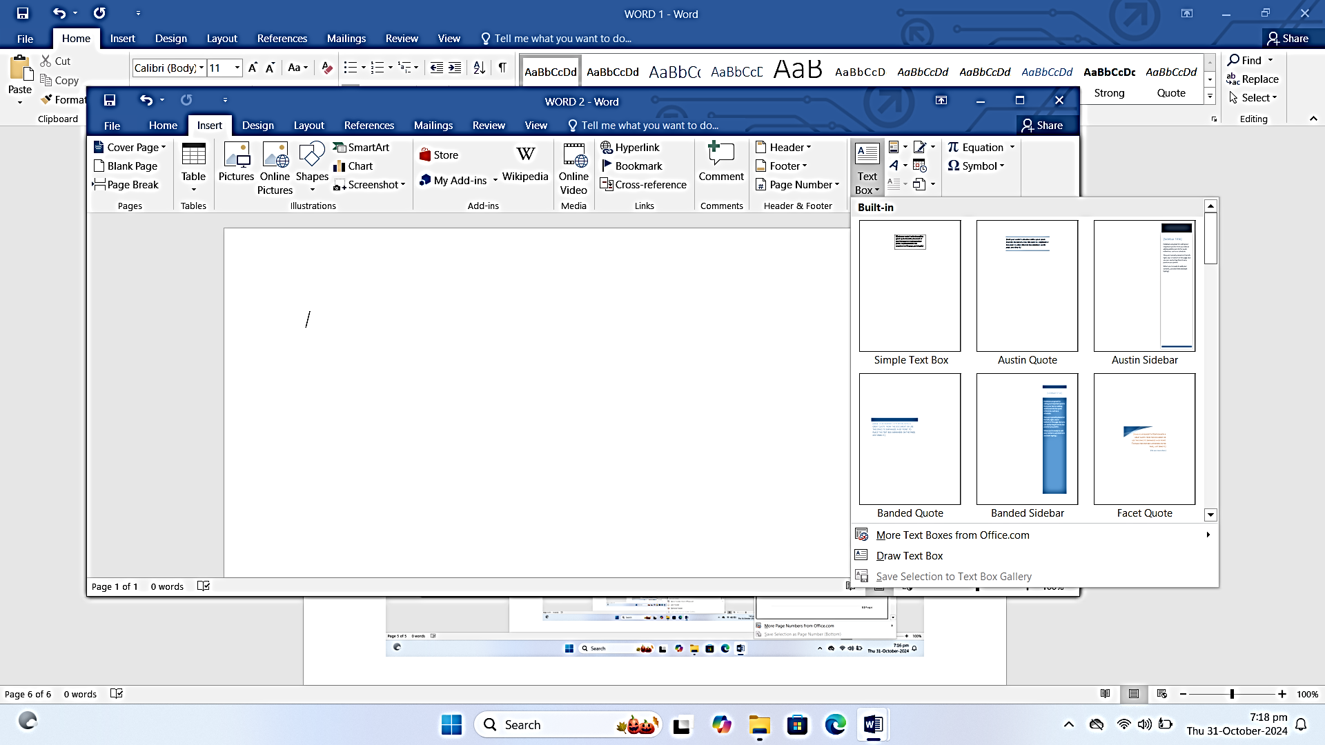

Under the insert tab on the right hand near the page number and click on text boxes, draw a text box and resize it by dragging the corners and customize by changing the back ground color, add borders or align text within the text box.

***WORD ART***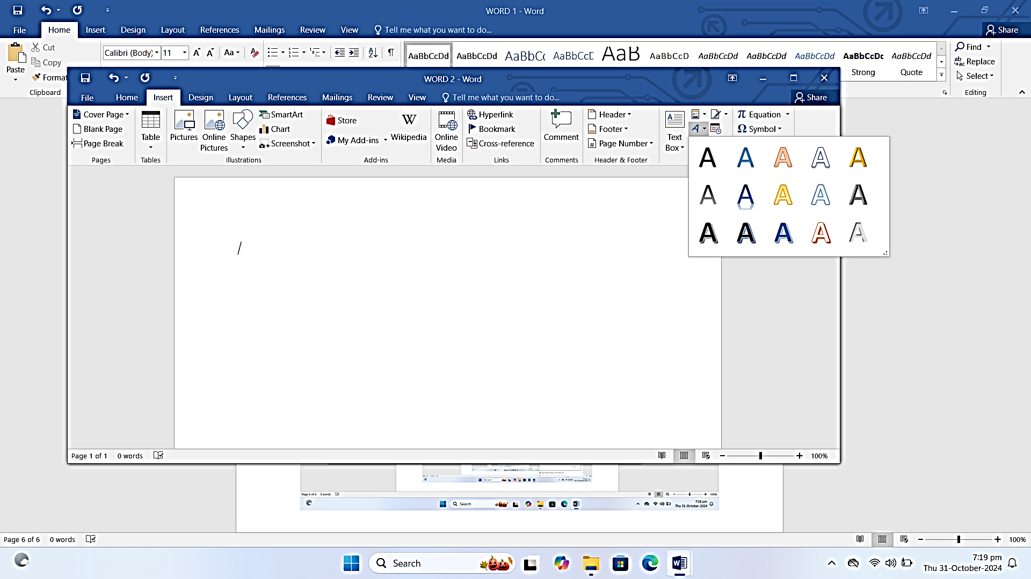

*Go to the insert tab and select word art, choose the style, format the word art and move or resize.*

***CITATION***

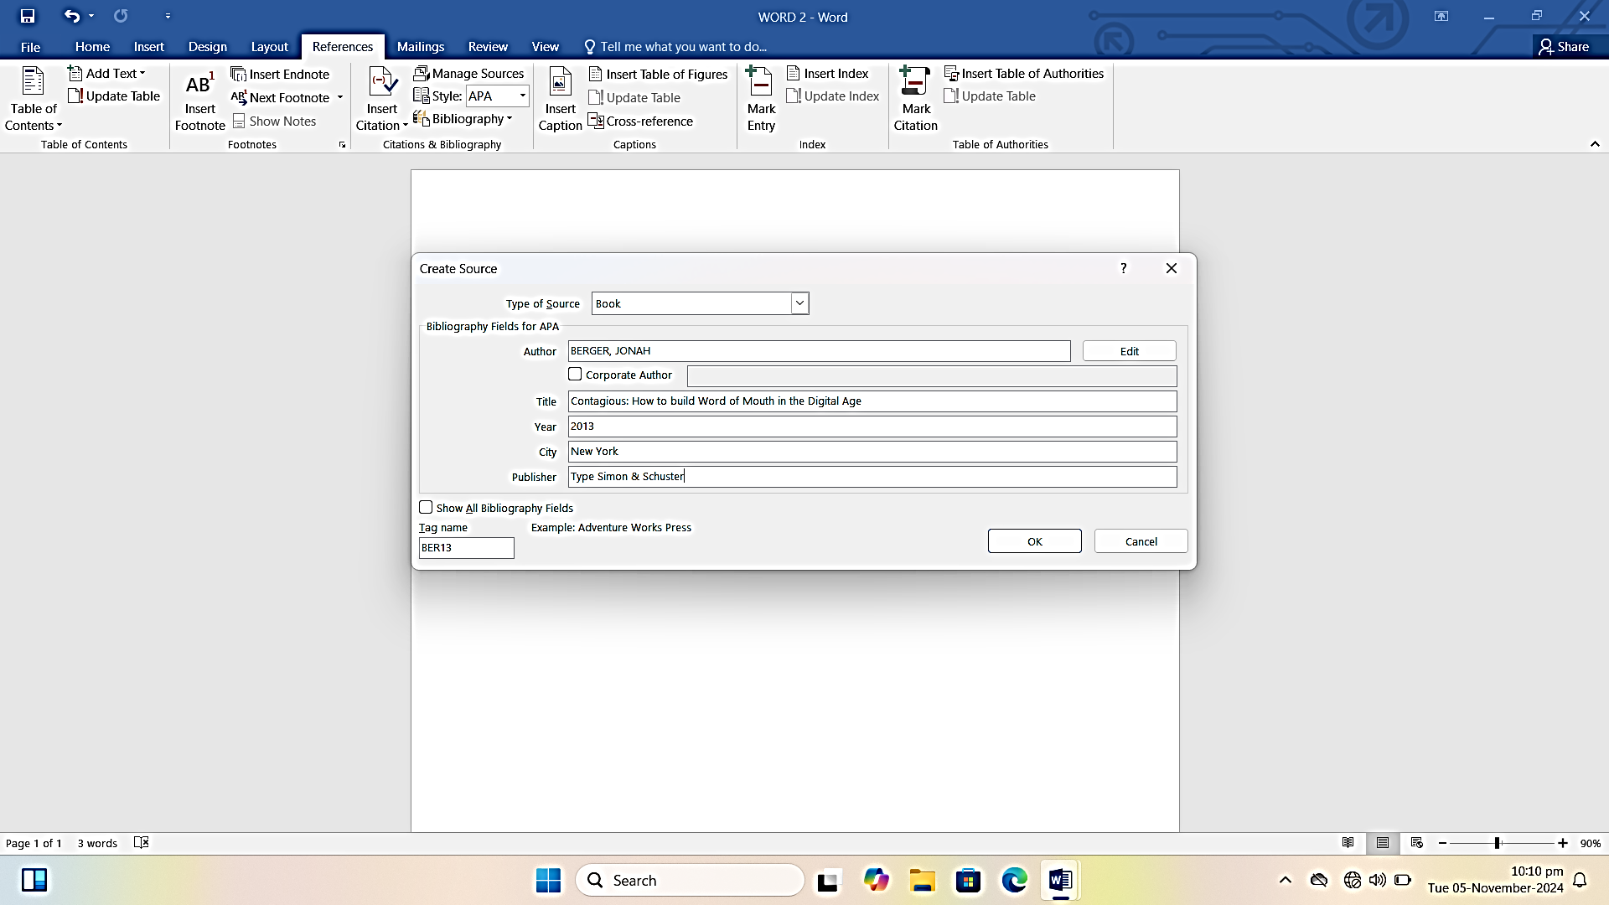

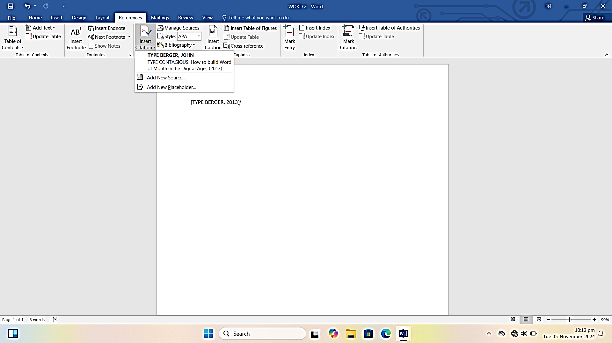

Adding Citation and a bibliography

Go to the reference tab, click on insert citation and choose Add New Sources. Select the source type and fill out the details, click OK to insert the citation in your document and to add bibliography, go to the references tab, click Bibliography and select a style to automatically generate a list of references,

ADD BIBLIOGRAPHY

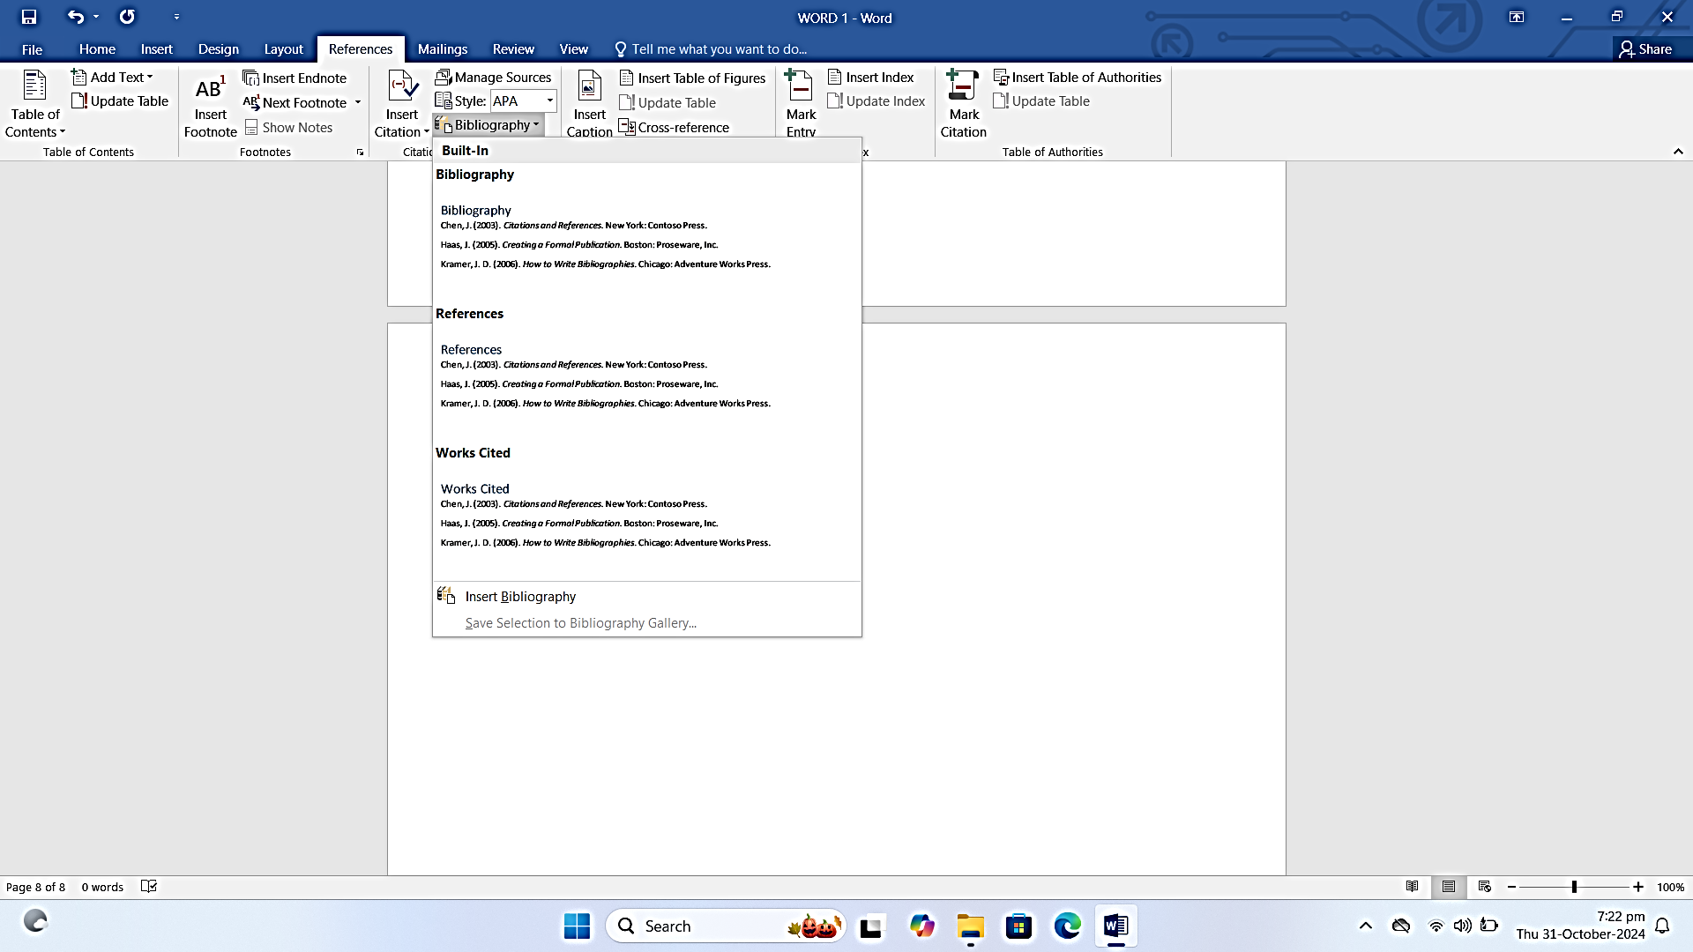

FORMATING CITATIONS AND BIBLIGRAPHIES.

ADDING CAPTIONS’

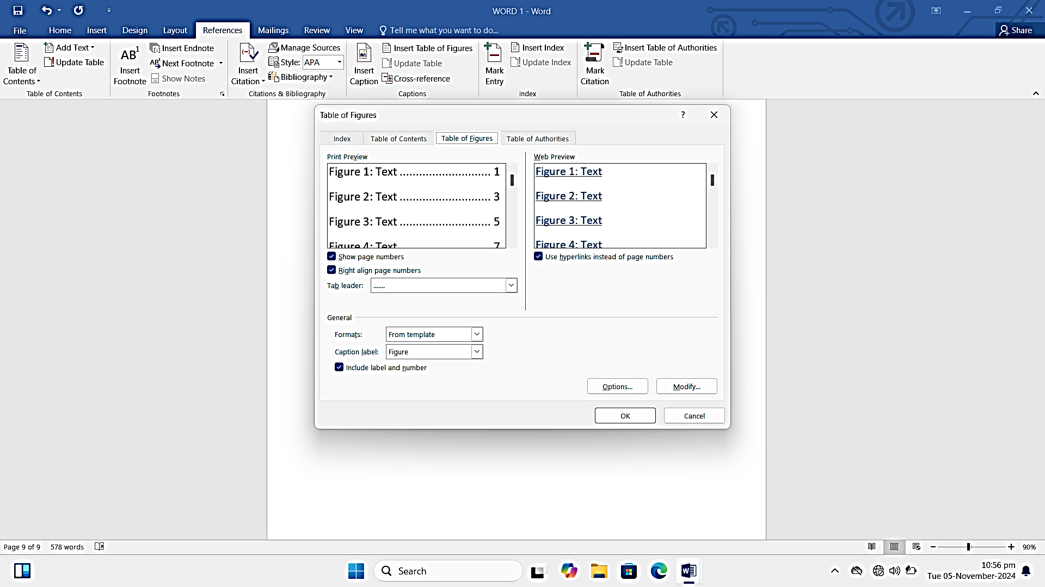

Select the item you want to caption like image or table

Go to the references tab and click Insert

Caption choose a label like figure, table and enter a description

Click OK to insert the caption